Hiring Official
ATTACHMENT 6

The Approving Official (AO) will determine which method of reimbursement is appropriate for casual employee travel expenses (through Concur.Gov or Optional Form (OF)-288) and if appropriate, submit to the Casual Payment Center (CPC) for processing.

Travel reimbursement process

Under terms of the Casual Hire Travel Expense Reimbursement Waiver, casual employees may claim the following travel expenses on the OF-288 form:
- Privately Owned Vehicle (POV) mileage;
- Incidental expenses; and
- Maximum of 15 meals per emergency incident.

The CPC staff will validate, as accurate, the allowable per diem rate and mileage rate claim on each reimbursement form/request and process the OF-288 for payment. They will work with the hiring location to ensure the casual’s pay on the OF-288 is not delayed pending travel reimbursement issues. When travel issues cannot be resolved, (e.g. there are lodging or other receipts that need to be paid through Concur.Gov), the CPC will remove the travel claims from the OF-288 and process only the casual’s payroll.

HOW TO SUBMIT TRAVEL EXPENSE REIMBURSEMENTS

BATCH MEMO: As part of the batch approval process, the AO will certify that the OF-288s are accurate, appropriate, and legal for payment. An Incidental Expenses (IE) box has been added to the batch memo indicating all casuals submitted in the batch should be reimbursed for incidental expenses. Starting and Ending Dates should be completed by AO. The CPC will then add dates and totals to each OF-288 in the batch.
**Please note IE reimbursement payments will be made to the corresponding fire code as indicated by date on the OF-288. For example, columns A & B have fire code J7PW, and column C has fire code J7LN, the IE reimbursement will be applied to the dates and fire code in columns A & B (J7PW) and the dates and fire code in column C (J7LN).

OF-288: Within Box 18. Commissary and Travel on the OF-288, incidental expenses can be indicated along with applicable dates and any POV reimbursement mileage. Ensure the applicable dates for IE are indicated on the first OF-288 only. It is not necessary to document travel reimbursements on each OF-288.

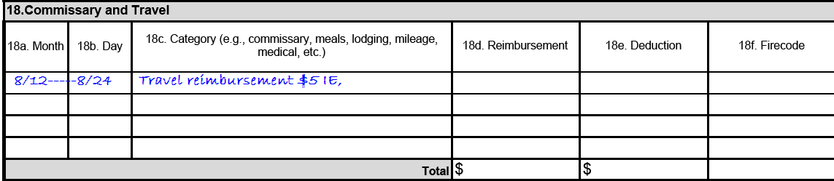

TRAVEL WORKSHEET: A Travel Worksheet can be attached to either the Batch Memo (crew reimbursement) or an OF-288 (individual reimbursement). When listing crew names, only indicate ECI number if you have ADs with the same or similar last names, or common names.

