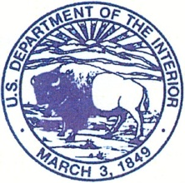
United States Department of the Interior

BUREAU OF INDIAN AFFAIRS
NATIONAL INTERAGENCY FIRE CENTER
3833 South Development Avenue
Boise, Idaho 83705-5354

(Supervisors use this template for each employee)

XXXX, XX, 2013

To: Paul Holley, Division of Safety and Risk Management

From: Supervisors Name

Subject: Motor Vehicle Operator Certification of Eligibility and Authorization Card

Attached for your consideration is the driving record for the past three (3) years of employee
name. Included in this package are the following documents:
- Completed GSA Form 3607
- Current Defensive Driving Certificate

As the certifying official, I have completed and signed Section V, the Certification and Eligibility and Authorization portion of the 3607 form. You are the approving official and the determination to issue the Motor Vehicle Operators Authorization Card is your responsibility.

As employees name supervisor, I have informed them of the policy of alcohol and controlled substance use is strictly prohibited while in performance of official duties. I have also reinforced the use of seat belts, and the prohibited use of texting while operating a motor vehicle as outline in Executive Order 13513, dated October 1, 2009.

Currently, employees name does/does not possess a current ` Motor Vehicle Operators Authorization Card.

Please feel free to contact me at (XXX) XXX-XXXX or via email at: supervisors email address

