Forest Pathology and Entomology:
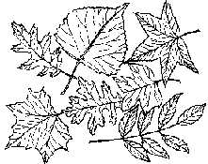
Diagnosis, Assessment, and Management

by Linda Haugen, Plant Pathologist; USDA Forest Service; S&PF; St. Paul, MN
(updated for BIA Partners in Action, June 2015)

“The four parts of this talk will include diagnosis, assessment, intervention, and examples of common problems. You will learn how to figure out what might be wrong with your trees based upon patterns of symptoms on the tree and on the landscape. We will discuss when intervention is needed, versus when disease damage is really inconsequential. We will use some commonly encountered forest health problems to walk you through the process of diagnosis and assessment.”

- Steps in Diagnosis
Step 1: Identify the host and determine if plant growth is normal.
Step 2: Collect site information.
Step 3: Collect host information.
Step 4: Consult references and make a diagnosis.
Step 5: Submit plant samples for laboratory analysis.
Some forest health problems may require all five steps for diagnosis; others may be easily diagnosed after one or two steps. The individual steps will be more fully explained below.

Step 1: Identify the Host and Determine if Plant Growth is Normal.
The initial step is often to recognize that a problem exists. Is something abnormal? Are trees showing stress? It can be important to recognize what is normal plant growth versus senescence. An example could be normal senescence of older conifer foliage in the fall which you may mistake for a disease problem. Observing annual growth rings, seed production, or the length of branch internodes can be valuable in identifying abnormal growth patterns. Many pest problems occur only on certain tree species. An accurate identification of the host plant will greatly simplify the diagnostic process by narrowing down the list of possible pest problems to those that have reported to occur on a particular host

Step 2: Collect Site Information
Observe the distribution of damage on the site and look for patterns in symptom distribution and symptom occurrence as they relate to site conditions.

A. Site conditions
Information about specific site conditions should be obtained and may be critical for an accurate diagnosis.
- Know soil characteristics (type, pH, percent organic matter) and determine if the tree species or provenance is suited for the site.
- If host and site are not well suited, be on the lookout for symptoms of general decline, and disease and insect pests that attack weakened, stressed trees.
- Know the management history of the site, and consider recent stand management operations or other activities that may have caused site disturbances.
- Investigate recent weather patterns and be aware of episodes of extreme cold or heat, drought, high winds, lightning, hail or ice

B. Patterns of symptom distribution on the site — what they may indicate:

Symptoms often develop in specific patterns (e.g., low areas or along roadsides) and often indicate particular plant problems. See Table 1 for examples of symptom distribution patterns that occur on a particular site and possible causal agents.

Table 1. Patterns of Symptom Distribution on the Site and Possible Causal Agents.

Patterns of Symptom Distribution | Possible Causal Agents
Groups of plants in low areas. | Abiotic: frost and winter injury, flooding and pesticide concentration  Biotic: diseases favored by high humidity and soil moisture
Groups of plants in high areas. | Abiotic: nutrient deficiencies, drought and wind injury  Biotic: secondary insect and disease pests that attack weakened and predisposed trees
Most of trees near the edge of a stand or planting. | Abiotic: Management activities that create stand edge effects, and induce stress associated with increased soil temperatures, reduced soil moisture levels, and increased wind damage.  Biotic: movement of insect or disease pests from nearby tree species or windbreaks.
Groups of plants under the canopy of older trees. | Biotic: diseases and insect pests that move from the infested overstory trees to the understory trees and are favored by high humidity, shade, or feed on smaller diameter shoots.
Groups of plants along roadways. | Abiotic: de-icing salts or herbicides applied for weed control.

C. Patterns in symptom occurrence on the site -- what they may indicate.
Determining when symptoms first appeared can be key information to the accurate diagnosis of diseases and injuries. For example:
- Know when symptoms first appeared and determine if recent weather conditions or site disturbances may be responsible for plant damage.
- Have the symptoms been ongoing for a number of years? If so, how long and what occurred prior to the onset of symptoms?
- And finally, ask if symptoms occurred suddenly, without progression. Sudden death, without progression, is most typical of injuries caused by nonliving causal agents such as chemical burn and short duration weather events including lightning strikes, high winds, and freezing temperatures.

Step 3: Collect Host Information.
At this step, we move away from the broader view of site characteristics and focus our attention on the individual tree. Systemically examine all parts of the tree for signs and symptoms and record your findings. Look for patterns in how the damage is distributed within the tree and identify what plant parts are affected.

3a. Patterns of symptom distribution on the host -- what they may indicate
Symptoms often develop in specific patterns within a tree, e.g., top-down, bottom-up. Determine how the damage is distributed within the plant. Knowing the pattern of symptom distribution can provide valuable clues as to possible causal agents. See table 2 for examples.

Table 2. Patterns of Symptom Distribution on the Host Plant and Possible Causal Agents
Patterns of Symptom Distribution | Possible Causal Agents
Top-down; Outside in  This pattern is typical of damage caused by agents that disrupt the absorption and translocation of water and nutrients from the roots to the foliage. | Abiotic: improper planting techniques, drought and mechanical injury to roots, stems or main branches.  Diseases: vascular wilt, canker and root diseases.  Insects: root feeding, wood boring and some leaf feeding insects.
Bottom-up; Inside-out  This pattern is typical of biotic agents that require high humidity, leaf surface water, or physical protection from desiccation, wind and rain. | Diseases: leafspot and needle cast diseases.
One-sided.  This pattern is typical of damage caused by agents that affect one side of the tree. | Abiotic: de-icing salt or herbicides applied to roadways, mechanical injury to roots.  Diseases: diseases that colonize one portion of the root system or the main stem.
All over  This pattern is typical of abiotic agents and some very fast moving biotic agents. | Abiotic: episodic weather events such as frost, winter injury, lightning strikes, high winds, hail or ice storms, drought, chemical injury and air pollution.  Diseases: a small number of diseases that invade the conducting tissues can kill trees within a few weeks.  Insects: insects that rapidly colonize and destroy the phloem and outer xylem such as bark beetles.

3b. Categorize symptoms and signs by plant part affected.
The type and location of symptoms and signs present on the host plant will often indicate the cause of the damage. In the following section we have provided some “general rules of thumb” regarding commonly associated symptoms of damage to various plant parts. Examining the plant for symptoms and signs will give you information you need to effectively use reference materials to identify a causal agent.

Roots and Root Collar
Damage to the root system of trees may be visible on the tree as a general decline or dieback in the crown or as whole tree death. It may also be visible as wilting, dwarfed leaves or other leaf symptoms throughout the entire crown. Damage to root strength may be visible as wind thrown trees. If you suspect that the root system is damaged, dig down and look at the roots.

Main Stem and Major Branches
Damage to the main stem or major branches prevents water and nutrients flow within the crown of the tree, so the damage may be first demonstrated as crown symptoms, such as dieback, wilting, chlorosis (yellowing) or death of foliage. Sometimes the damage will be readily evident on the stem— other times it will be “hidden” below the bark. On hardwoods with stem injury, there may be sprouting from the stem below the point of injury.
Although decay does not usually kill trees outright, it can weaken the stem of trees so that they break off. Some canker-causing fungi also cause a decay of the wood.

Vascular System
Pathogens that systemically infect conducting tissues (xylem and phloem) within the vascular system of trees impair the transport of food, water and nutrients between the roots and foliage. Vascular infections within trees are often fatal and can be caused by fungi, bacteria, phytoplasmas and nematodes.

Shoots/Twigs/Buds
Shoot and twig damage can be distinguished from main stem and branch injury because the branch tissue is alive, but the shoot or twig is killed. Use a knife to cut into the bark and look for the margin between the live and dead shoot tissue.

Foliage
Leaves are indicators of general tree health and often give the first clue of trunk and/or root problems as well as problems affecting the leaves directly. Although problems that remain localized on the leaves, such as many leafspot diseases or leaf feeding insects, are often not seriously damaging to the overall tree health, repeated annual defoliation may weaken trees and predispose them to attack by insect borers, canker fungi or winter injury. Defoliation accompanied by drought stress or stress from poor site or growing conditions can seriously weaken trees, reduce growth and contribute to the development of dieback and decline.

Insect feeding guilds:

- Root feeders
- Bark beetles and wood-borers
- Shoot and twig
- Sucking
- Galling insects
- Defoliators
- Seed and cone

Helpful overview: http://www.myminnesotawoods.umn.edu/2007/04/forest-health-insects/

Step 4: Consult References and Develop a Diagnosis.
Experience will make some problems simple to diagnose, but often it is necessary to consult references. Many reference materials have good descriptions of the pests and their biology. Much information is now available on the www. It is still a good idea to have a few good books on basic tree health. A few good references, and several internet sites, are listed near the end of the handout.

Step 5: Submit plant samples for laboratory analysis.
Sometimes you’ll need to submit a sample to a lab for diagnosis. Understanding what plant part is affected will help you to collect an adequate sample. Being able to describe the site, the distribution on the site, the timing of when symptoms occurred, and how the symptoms are distributed on the host plant may make the difference between a correct diagnosis and an answer that comes back “inconclusive”. The internet www addresses for the University extension insect and disease diagnostic labs in IA, MN, MI, and WI are listed near the end of the handout. Each lab provides information on how to collect a good sample, where to send it, and what fees are involved.
Sources of additional information/assistance

Information: Web resources, Publications
Services: Diagnostic labs
Services: State services to landowners…
- DNR: Iowa, Wisconsin, Minnesota, Michigan
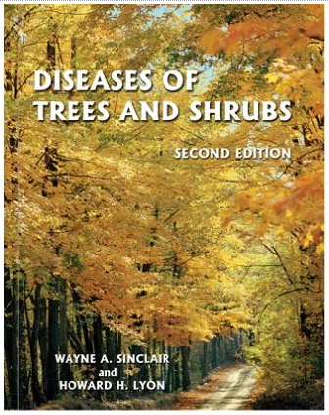
- Extension: Iowa, Wisconsin, Minnesota, Michigan
Consulting services, contractors

KEY PUBLICATIONS:
The following two reference books are very good resources with detailed information on many tree pests as well as great photographs. The price range for each is around $60 from internet booksellers.
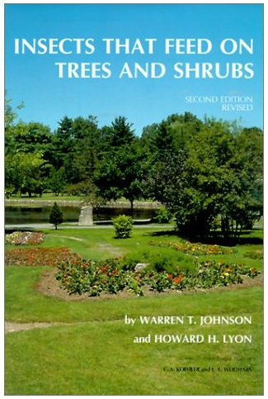

Diseases of Trees and Shrubs, Second Edition. 2005. by Wayne Sinclair and Howard Lyon.

Insects That Feed on Trees and Shrubs. 1991.
by Warren T. Johnson, Howard H. Lyon
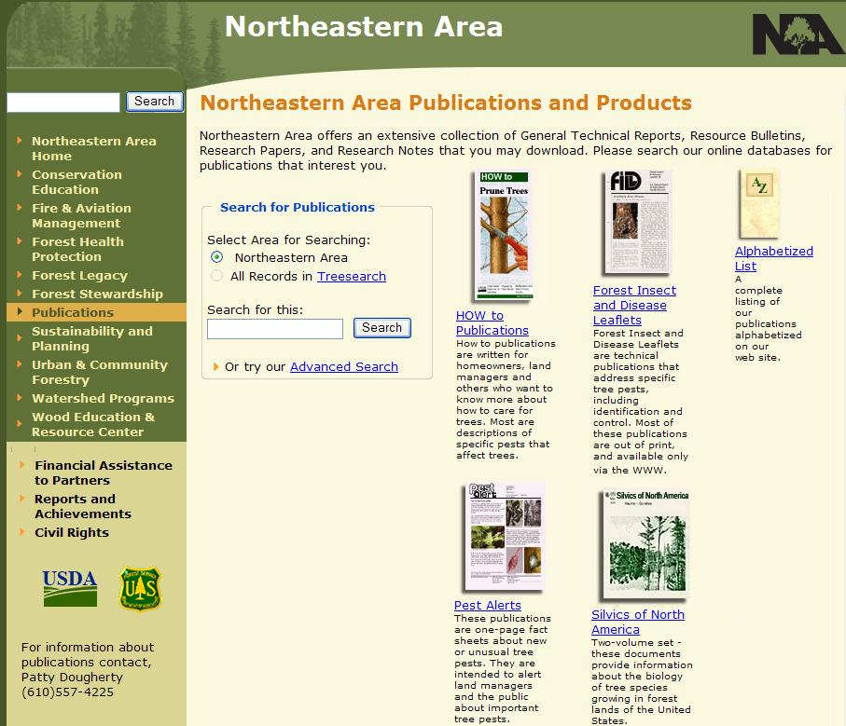

Many Forest Service Publications related to trees and tree health are available on the www. These include many “How to” publications as well as Pest Alerts and other pubs.
http://na.fs.fed.us/pubs/index.shtm

The following older Forest Service publication is still valuable, and is available on the www.
USDA Forest Service. 1979. A guide to common insects and diseases of forest trees in the northeastern United States. Northeast. Area State Priv. For., For. Insect and Disease Management., Broomall, PA. p. 123, illus. http://www.forestpests.org/northeast/index.html

Another good place to get info on tree diseases is University Extension publications and websites:

Wisconsin Extension factsheets on deciduous trees and shrubs (for purchase, but some free electronically): http://learningstore.uwex.edu/

Iowa State University Extension publications distribution/index page:
https://www.extension.iastate.edu/store/

University of Minnesota Extension webpage, “My Minnesota Woods”:
http://www.myminnesotawoods.umn.edu/

Michigan State University Extension forestry webpage:
http://msue.anr.msu.edu/topic/info/forestry

I also often look for information from adjacent States that might have similar growing conditions and forest health issues… Indiana, Ohio, even Canada…

Some other contact information for diagnostic labs and services to landowners:
Iowa
Diagnostic Lab (diseases and insects): http://www.ent.iastate.edu/pidc/
DNR Forest Owner Assistance: http://www.iowadnr.gov/Environment/Forestry/ForestryLandownerAssistance.aspx
ISU Forestry Extension’s home page: http://www.extension.iastate.edu/forestry/
Extension’s list of “forestry assistance in Iowa”: http://www.extension.iastate.edu/forestry/links/contacts.html

Wisconsin:
Diagnostic Lab (disease) : http://labs.russell.wisc.edu/pddc/#
Diagnostic Lab (insect): http://www.entomology.wisc.edu/diaglab/
WI DNR’s Landowner page: http://dnr.wi.gov/topic/ForestLandowners/
Wisconsin DNR Forest Health page: http://dnr.wi.gov/topic/ForestHealth/
UW extension “caring for your woodland” site: http://woodlandinfo.org/content/forest-health

Minnesota:
Minnesota Extension diagnostic guide: http://www.extension.umn.edu/garden/yard-garden/
Diagnostic Lab (disease): http://pdc.umn.edu/
University of MN extension insects webpage: http://www.extension.umn.edu/garden/insects/
Univ of MN Forest Entomology Lab website: http://www.forest-insects.umn.edu/
Minnesota DNR stewardship webpage: http://www.dnr.state.mn.us/foreststewardship/index.html

Michigan:
Michigan State University Diagnostic Lab: http://www.pestid.msu.edu/
Michigan DNR Forest Stewardship Program: http://www.michigan.gov/dnr/0,4570,7-153-30301_34240_68762---,00.html
Michigan Forestry Assistance Program (FAP): http://www.michigan.gov/mdard/0,4610,7-125-1599_28740-286087--,00.html

B. Figuring out whether a situation needs intervention
  - Is this serious/lethal?

  - Will it spread/increase?

  - Is there anything you can do about it?

C. Case Studies: Some specific problems you may encounter…
 | Diagnosis/symptoms | Assessment
Case 1:  Oak Wilt | Host is oak (particularly red). Distribution on site is an expanding pocket of dead trees, with another few trees dying each year. Whole trees die quickly, leaves drop off. Leaves appear “water soaked”. Vascular wilt disease… affects water conducting tissue in main stem. | This is a serious tree killer. It spreads underground to adjacent trees through root grafts. It also spreads overland via insect vectors to start new pockets. What you can do depends on the accessibility of the site, management objectives, and value of your resource. Use management activities to stop pocket expansion, and reduce formation of new pockets.
Case 2:  Oak Anthracnose | Host is often white oak. Common following prolonged wet periods in spring and early summer. Lower, inner portions of crown most heavily affected; Individual leafspots anywhere on leaves. Spots coalesce into large, brown blotches. Leaves may curl or twist. Leafdrop may occur. | Does not cause outright mortality. May be “inciting factor” in decline.
Case 3: Heterobasidion Root Disease | Host is pine. Damage is in an expanding pocket. Causes decline and eventual whole tree death. Conks may be present in the fall on killed/dying trees and stumps. | Can cause extensive damage to pine resource once it becomes established in a stand. Enters through stumps, and then spreads to adjacent trees. Prevention by protecting cut stump surfaces from infection.
Case 4:  Red Pine Shoot Blights | Host is red pine. Damage is on lower shoots and seedlings/saplings in the understory. Damage is on shoots, causing death of all needles on affected shoots. | Can cause death of young trees, or growth loss and deformity. Manage by avoiding multi-story red pine canopy.
Case 5:  Ash Anthracnose | Host is ash. Season is spring. Weather conditions have been moist. Leaves are falling off ash, dropped leaves have spots. Damage seems to be limited to the leaves… twigs and main stem unaffected. | Generally a light level of defoliation is not consequential to health of tree. The level of damage is highly related to moisture conditions. It can spread, but is generally found everywhere. In a yard you can rake and destroy leaves, in woods there is no practical treatment.
Case 6:  Emerald Ash Borer | Host is ash. Only ash trees affected. Sparse foliage and dead branches or dieback in crown. Trees decline over period of 2-4 years, and then die. Epicormic sprouting on main stem or base may occur, but not “witches brooms”. D-shaped exit holes on branches and trunk, larval galleries under the bark. | This is extremely serious. EAB kills healthy trees, and it spreads readily and rapidly. EAB is not yet present throughout all of the potential affected range, so quarantines are in place. It can be transported long distances in firewood, logs, and nursery stock.

