Current view of TAAMS Main Screen 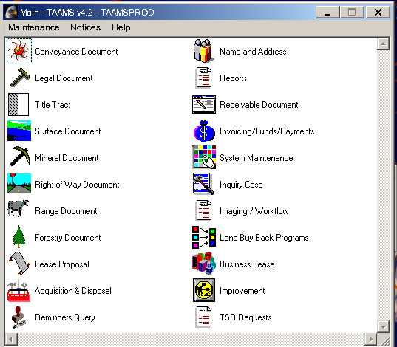

View of the Main Screen after the Modernization change
