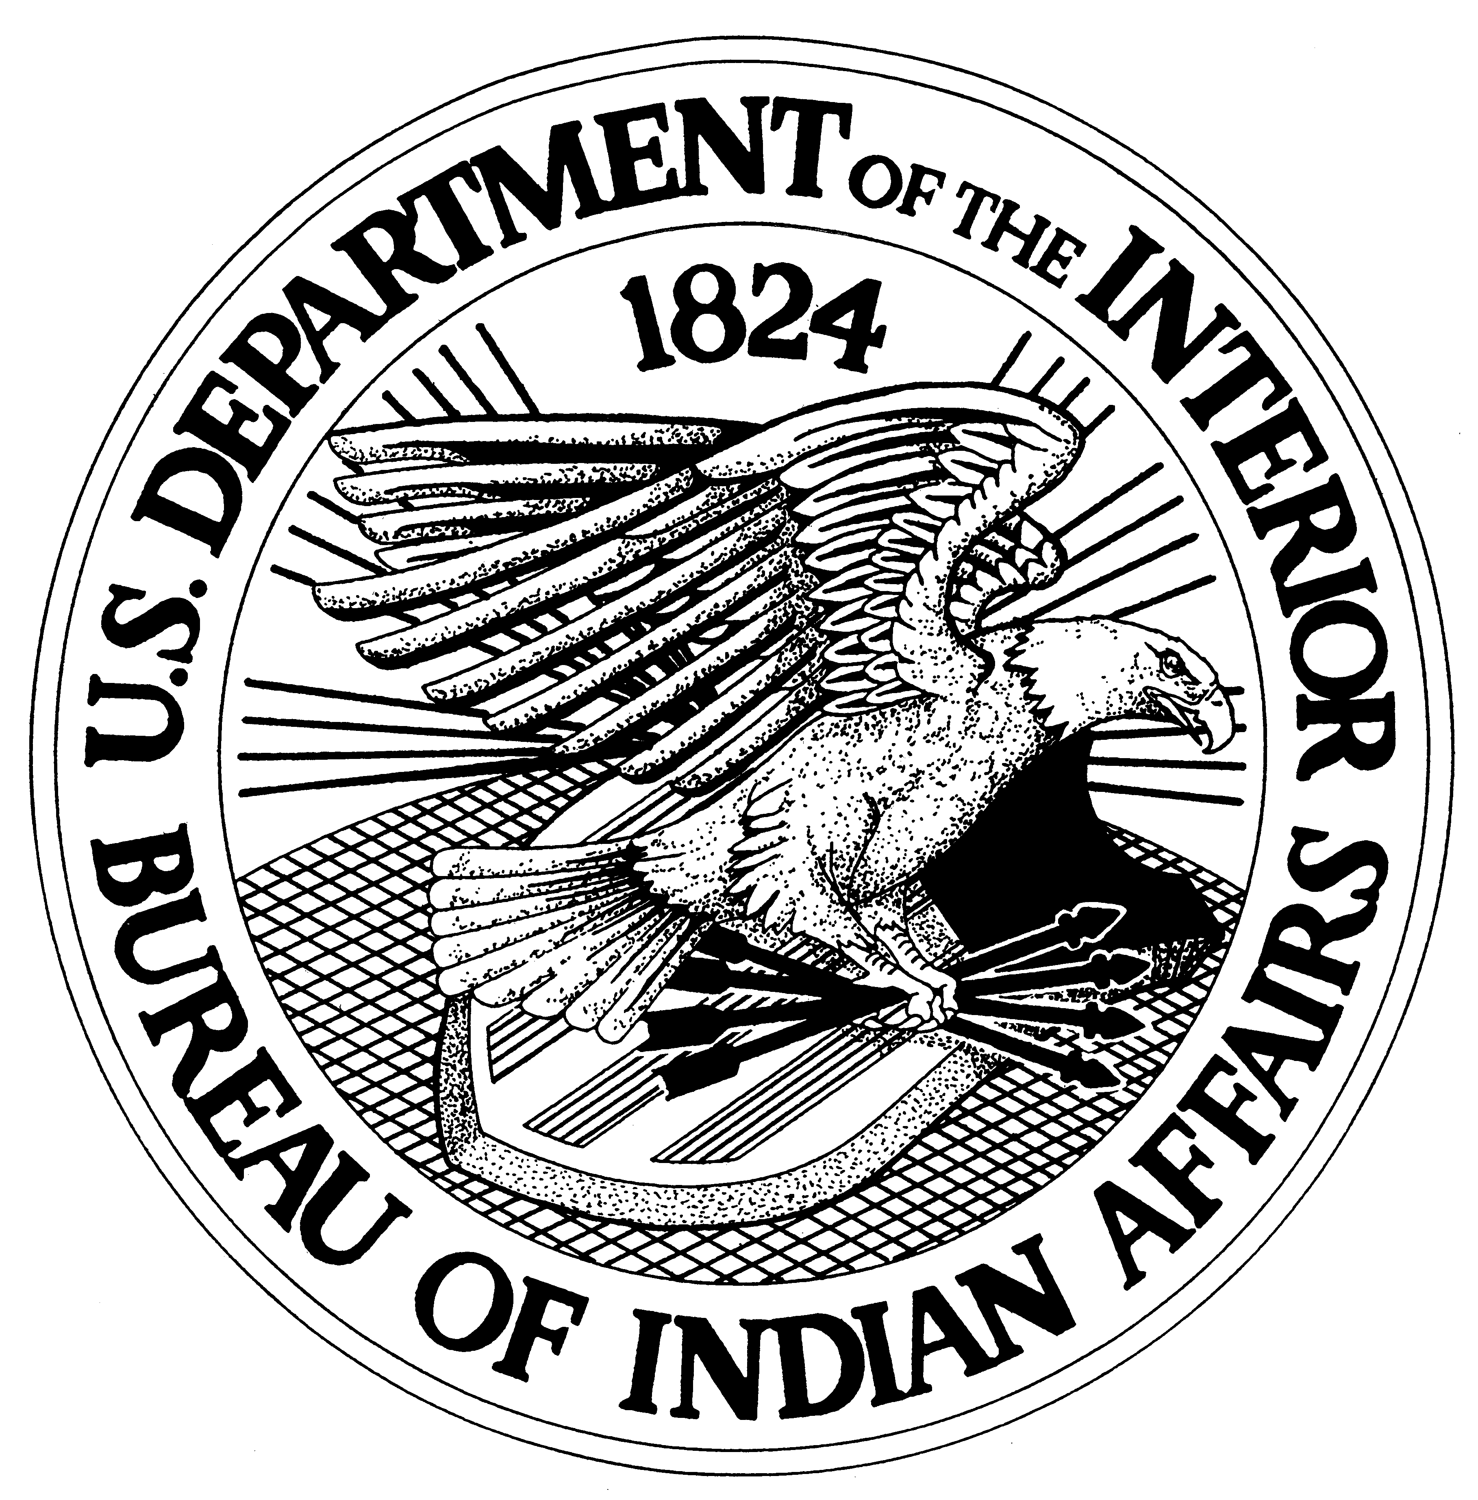
BIA Burned Area Emergency Response (BAER) Team Nomination Form
APPLICATION PROCEDURE: Nominations must be submitted with the employee’s supervisor’s signature and emailed or faxed to Darryl Martinez at Darryl.Martinez@bia.gov or faxed to 505-563-3052 no later than March 31, 2014.
Nominee’s Name (First MI Last):

Working Job Title: |  | E-Mail:
Tribe/Agency Name: |  | Cell #:
Home Unit: |  | Mailing Address (if different):
Street: |  | Street:
City: | State: | City: | State:
Zip: | Telephone: | Zip: | Telephone:
List BAER Position(s) applying for:
List training completed and dates pertinent to this position:

List your current and past qualifications pertinent to this position, including red card (IQCS):
List if you’re interested in a Local/Tribal team, Regional team or National team:
Nominee’s Signature:
Supervisor’s Signature:

