U.S. DEPARTMENT OF THE INTERIOR

BUREAU of INDIAN AFFAIR [BIA]

HOUSING IMPROVEMENT PROGRAM

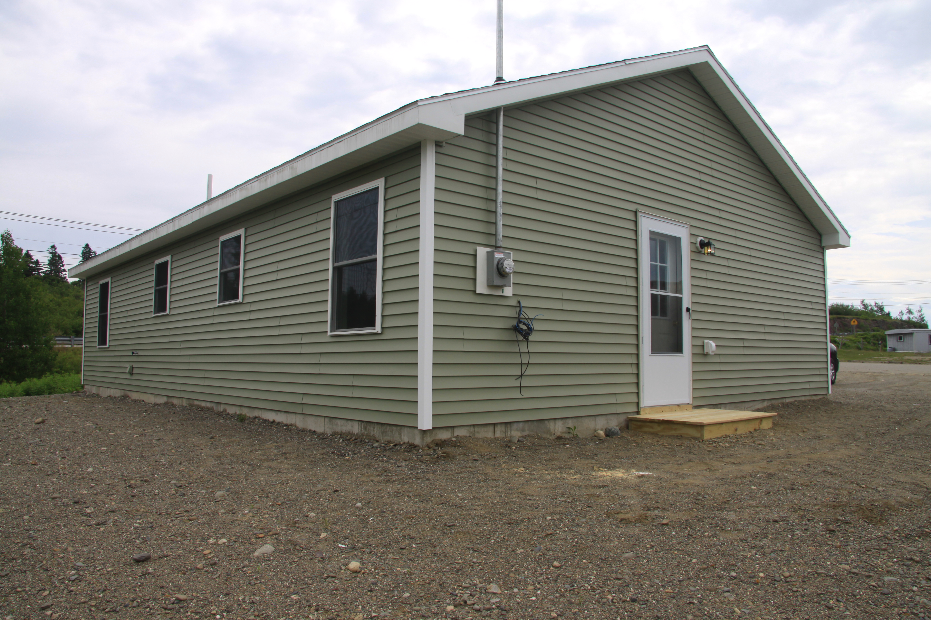

The objective of the BIA Housing Improvement Program is to assist needy Indian families who have no other recourse for housing assistance, in the immediate or near future, in attaining a decent, safe and sanitary living environment.

WHAT IS HIP?
HIP is a home repair, renovation and replacement program administered by the Bureau of Indian Affairs and federally recognized Indian Tribes. The Snyder Act, 25 USC 13, provides the mechanism by which the Bureau of Indian Affairs has established the Housing Improvement Program (HIP), under 25 C.F.R. §256. The purpose of this safety net program is to provide assistance to needy Indian families living in or near reservation communities within approved tribal service areas, who have limited resources and who are otherwise unable to obtain assistance from other housing programs.

The Department of Housing & Urban Development has primary responsibility for new housing in Indian communities, while the emphasis of the HIP is on repair, renovation and replacement of existing housing. Approximately 52 percent of eligible program applicants need repair, renovation or replacement assistance, with the remaining eligible applicants requiring new housing.

Approximately 95 percent of the tribes that have eligible applicants operate the program through Pub. L. 93-638, Self-Determination agreements or Self-Governance compacts. The remaining eligible applicants receive program services directly from the Bureau of Indian Affairs.

Eligibility- a HIP grant recipient must be a member of a Federally-recognized American Indian tribe or Alaskan Native village; and, be living in an approved tribal service area; and, have an annual income that does not exceed 125% of the Department of Health and Human Services Poverty Guidelines.

To access a list of tribes, you may download the Tribal Leaders Directory, which provides a tribes’ name, address, phone, and fax number for each of the 566 Federally-recognized Tribes, please go to the BIA website.

http://www.bia.gov/WhoWeAre/BIA/OIS/TribalGovernmentServices/TribalDirectory/index.htm
There may be an email or website address listed for the tribal entity if they have provided it to the BIA.
HOUSING PROGRAM SERVICES
Interim Improvements - the program provides up to $2,500 in housing repairs for conditions that threaten the health and/or safety of the occupants.

Repairs and Renovation- the program provides up to $35,000 in repairs or renovation to improve the condition of a homeowners dwelling to meet applicable building code standards.

Replacement and Housing- the program provides a modest replacement home if the homeowner’s dwelling cannot be brought to applicable building code standards within the cost limitation cited for repairs and renovation; or, if you do not own a home but have ownership or lease of sufficient land suitable for housing.

APPLICATION PROCEDURES
The BIA Housing Assistance Application Form 6407 and the Tribal Annual Performance Report Forms are available on the BIA website at

http://www.bia.gov/WhoWeAre/BIA/OIS/HumanServices/HousingImprovementProgram/index.htm

Applications may also be obtained from and submitted to your local servicing Tribal office or nearest BIA housing office. Complete guidelines can be obtained by consulting the Code of Federal Regulations (25 CFR 256) or contacting your respective Regional Office:

Regional Office Address Phone No.

Great Plains 115 Fourth Avenue, SE, Aberdeen, SD 57401 (605) 226-7441
Southwest P.O. Box 26567, 1001 Indian School Rd., (505) 563-3747
Albuquerque, NM 87125
Southern Plains W.C.D. Office Complex, P.O. Box 368, Anadarko, OK 73005 (405) 247-6120
Rocky Mountain 316 North 26th Street, Billings, MT 59101 (406) 247-7964
Eastern 545 Marriot Dr., Suite 700, Nashville, TN 37214 (615) 467-6712
Alaska 3601 C Street Suite 1100, Anchorage, Alaska 99503-5947 (907) 586-7397
Midwest 5600 W. American Blvd, Suite 500 Bloomington, MN 55347 (612) 725-4528
Eastern Oklahoma 3100 W. Peak Blvd., PO Box 8002, Muskogee, OK 74402-8002 (918) 781-4647
Navajo P.O. Box 1060, Gallup, NM 87305 (505) 863-8486
Western 2600 N. Central Avenue, Phoenix, AZ 85004 (602) 379-3083
Northwest 911 North East 11th Ave, Portland, OR 97232-4169 (503) 231-6754
Pacific Federal Office Building, 2800 Cottage Way, (916) 978-6167
Sacramento, CA 95825

For Additional Information:
Mr. Les Jensen, Housing Program Officer
Juneau, Alaska
(907) 586-7397
Leslie.Jensen@bia.gov

