Bureau of Indian Affairs, Office of Indian Services

Division of Human Services

Webinar Training Event

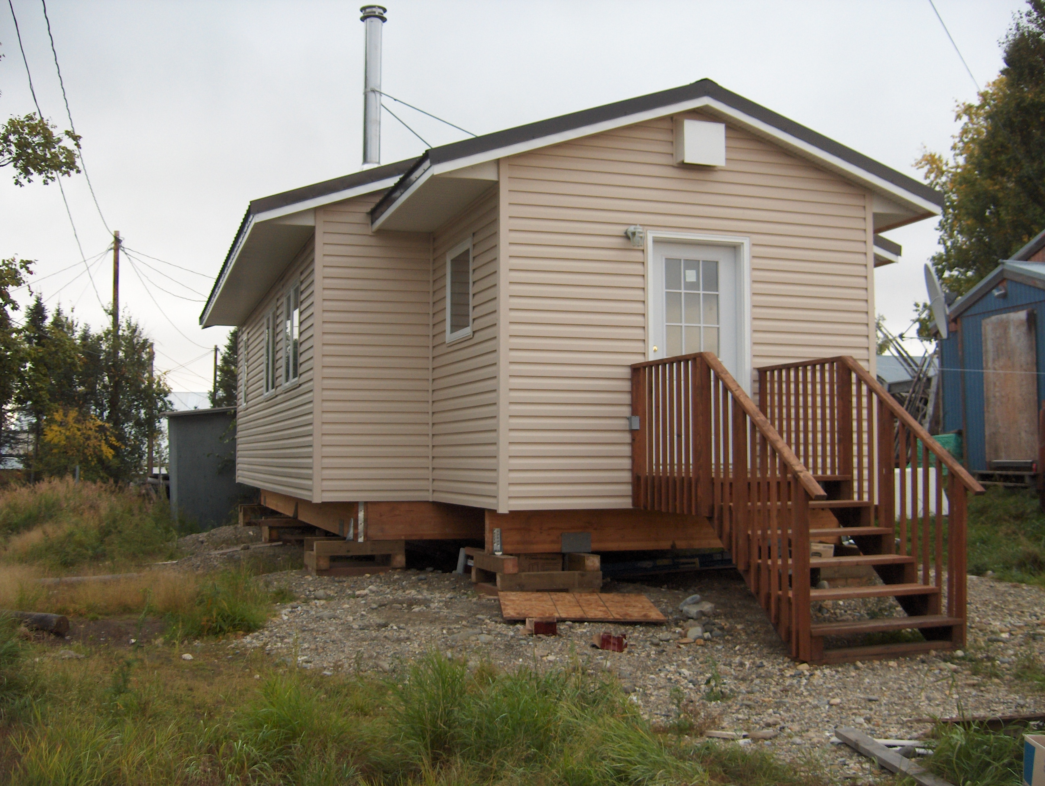

* **Webinar #1: Housing Improvement Program (HIP) Tribal Annual Performance Report**

**Date: Wednesday December 11, 2019 – 1:00pm to 2:30pm EST**

**Overview:** This webinar training session will provide an overview on the Housing Improvement Program Tribal Annual Performance Report (TAPR). The TAPR is due to the Regional offices December 31, 2019. The target audience for each webinar training session is tribal leaders, tribal program staff who operate the HIP, BIA Agency programs, BIA Superintendents and anyone interested in learning more about the BIA Housing Program.

Additionally, tribal entities should continue to seek Technical Assistance from the BIA agency or Regional Office who are responsible for all Bureau Housing Program activities within their defined geographical area.

To register for this webinar session, please click on the hyperlink below and use the event password, if prompted. You will need to use the event password to retrieve the Training Materials.

|  |  |
| --- | --- |
| **Webinar Training Session - HIP**  Date: Wednesday, Dec 11, 2019  Time: 1:00pm to 2:30pm EST  Call in telephone line #  Event Number: 877-417-9689  Event Password: 1730174 | Webinar Link: [https://bia-ois-hsevents.webex.com/bia-ois-hsevents/onstage/g.php?MTID=e91044594d84ed406a4f1cf2987edefb2](https://bia-ois-hsevents.webex.com/bia-ois-hsevents/onstage/g.php?MTID=e91044594d84ed406a4f1cf2987edefb2" \t "_blank)  Event Number: 824 264 367  Event Password:  nrdNmVut |

You can learn more about the Housing Improvement Program at:

<https://www.bia.gov/bia/ois/dhs/housing-improvement-program>

Point of Contact: Mr. Les Jensen, Housing Program Manager at [leslie.jensen@bia.gov](mailto:leslie.jensen@bia.gov)