** OFFICE OF TRUST SERVICES**

7/25/2018

**PATHWAYS INTERNSHIP PROGRAM**

**New Employee System Accesses On-Boarding Checklist and Guide**

*(For Students)*

**Purpose:** To guide the student through the systems on-boarding workflow processes within the DOI and BIA for requesting basic government information systems accesses.

**THS HAS RECENTLY BEEN CHANGED DUE TO SYSTEM CHANGES**

**PLEASE NOTE:** Ensure that you have the most current version of this document; if you have been handed a printed copy of this document, you may be using outdated material. Please contact your designated Pathways Program Coordinator to verify this form.

Click [here](https://www.bia.gov/sites/bia.gov/files/assets/bia/ots/nyrp/Acronyms%20and%20Commonly%20Used%20Terms%20%28Pathways%29.docx) for a list of **Acronyms and Commonly Used Terms (Pathways)** used throughout this guide.You can also go to our Pathways Internship Program at <https://www.bia.gov/bia/ots/workforce-planning-coordination> for a copy and other assistance.

During your first year as an intern, there will be 7 phases in the Pathways Internship Program. Depending on the appointment length you were hired, you can expect to repeat the last 3 phases until you graduate. Your Pathways Program Coordinator will assist you throughout these phases and for the duration of the Program.

**Phases: 1 2 3 4 5 6 7**

Onboarding

**Phase 3 (Pre-Employment)**

Step 1 Security Requirements, HSPD-12 credentialing, DOI ID Badge, and if applicable the Medical/Drug screening/tests

Step 2 Complete FISSA+ Training

Step 3 Email BIA Helpdesk to Update/Verify IIS e-Profile

**Phase 4 (New Employee Orientation)**

Step 4 Complete the Cardholder Travel Training and J.P. Morgan Cardholder Application Form

Step 5 Completes the ConcurGov System Access Request Form and Request Access

Step 6 Complete QuickTime Training and Request Access

Step 7 Activate BIA Email Account (BIA Host Office Work Site)

***Automated Account Deactivations/Terminations (Applicable to all Employees)***

The following system’s access will be terminated after LWOP action processed or days of inactivity.

|  |  |  |
| --- | --- | --- |
| When | System | Process to Reactivate |
| LWOP action (automatic with FPPS) | **SmartCard**  **(aka Govt. ID)** | LWOP action processed in FPPS will automatically deactivate SmartCard in DOI Access, which deactivates the Active Directory (AD) the next day. As soon as HR processes LWOP or termination action, card is deactivated.  To reactivate, the following steps must be completed in this exact order:   1. HR processes RTD action 2. HR re-Sponsor’s student in DOI Access (they do not have to re-credential) 3. HR notifies Central Office steps 1 & 2 completed 4. Student completes annual **FISSA+** and Cyber Security Trainings in DOI Learn (All federal employees must do this) 5. Central Office or Student emails training certificates to BIA helpdesk at biahelpdesk@bia.gov and requests to “Reactivate AD and Email accounts” **and**   “cc” Program Coordinator/Central Office  Check DOI Access Card Status and Site: https://doiaccess.doi.net/app/ |
| 30 days of inactivity  (automatic after not logging in) | **BIA Email and Active Directory (AD)** | Student emails BIA helpdesk at biahelpdesk@bia.gov to request " Reactivate Email and ADAccounts” **and**  “cc” Pathways Program Coordinator |
| 30 days of inactivity (automatic after not logging in) | **QuickTime** | Student emails the Master Administrator at [carl.cook@bia.gov](mailto:carl.cook@bia.gov) to request “Being taken out of a Suspended Status” **and**  “cc” Pathways Program Coordinator |
| Central Office Suspension Request to A/OPC | **JP Morgan Travel Card** | Central Office emails A/OPC to request “Reactivate JP Morgan Travel Card” |
| 365 of inactivity  (automatic after not logging in) | **ConcurGov** | Student emails DOI Travel Help Desk at travel_helpdesk@ios.doi.gov to request “Reactivate ConcurGov Account” **and**  “cc” Pathways Program Coordinator |

***NOTE: This is After you receive a Tentative Selection Offer Letter from HR***

You are a “Selectee” contingent upon a Favorable Screening and clearance for Medical/Drug Testing

**Security Requirements, HSPD-12 credentialing, DOI ID Badge (Smartcard), and Medical/Drug (if applicable)**

There are two critical steps that must be completed by the applicant before issuance of a Smartcard: 1) submission of the BGI forms through e-QIP, and 2) HSPD-12 credentialing. After the successful completion of a FBI finger print check through the OPM, Personnel Security will issue a favorable screening. This is when HR will confirm the offer of employment and negotiate an EOD date.

The employee/student’s continued employment will be contingent upon the successful completion and adjudication of a full BGI. The investigation can take up to 6 months to complete. Following is the general overview of the process.

Your designated Pathways Program Coordinator/supervisor will monitor this progress closely to ensure forward movement:

* Human Resources (HR)
* Create a “sponsorship record” in the DOI-Access system and select “**Requires Network Access**”. When the record is created, HR normally will set the student’s status to FUTURE (Pending Favorable Screening).

NOTE: The card will not go to print until this is updated to Current.

* Both the selectee and supervisor will receive an Email notification from HSPD-12 to find the nearest credentialing location with instructions on how to enroll and complete credentialing.
* Also, when the sponsorship record is created, DOI-Access will auto create “Pending” AD request in a que called “DOI Access/Pending”.
  + - Supervisors and selectees should monitor the status of their sponsorship record in DOI access at <https://doiaccess.doi.net/app/>
* Send a e-QIP request form to Personnel Security to initiate the background investigation.
* If position requires, schedule **Medical/Drug Testing (Fire students).**
* Personnel Security
* Send the applicant an Email providing detailed instructions to complete e-QIP and BGI requirements within 5 days.
* Selectee (Student)
* ****Complete e-QIP online forms and upload required documents. When instructed, send signed original security forms (i.e., release forms) to the Personnel Security office and HR.
* Login to the [USAccess GSA Online Scheduling System](https://timetrade.com/app/usaccess/workflows/usaccess001/schedule/?appointmentTypeGroupId=hspd12) to schedule an appointment to complete enrollment at the nearest Credentialing Center. Remember to bring valid IDs/Documents. Your photo will be taken and you will complete the **electronic fingerprinting.** 
  + - It is very important that the selectee respond immediately to requests from Personnel Security for additional information or clarification!
* Selectee works with HR to complete **Medical/Drug Testing** requirements. Appointments will be paid for by BIA and scheduled at the nearest facility. Again, this is only applicable if your position requires it.
* Personnel Security
* Review and release BGI packet in e-QIP.
* Release electronic fingerprints in the DOI Access system to OPM/FBI for a favorable screening.
* **Favorable Screening** determination.
* Update and “Adjudicate” the DOI sponsorship record as Favorable in Personnel Security Module.
* HR
* Change sponsorship record in DOI Access from future to CURRENT.
  + - This will release the Smartcard for printing which normally takes about 2 weeks.
    - The Smartcard will be sent to where you completed your enrollment Credentialing
* When the Smartcard have arrived, the Credentialing Center staff will send an Email titled “Credential/PIV Card Ready For Certificate Update” to both the supervisor and selectee with instructions.
* After the card is activated, the AD status will be changed from “Pending” to “Active” in DOI Access. Steps on how to activate a BIA Email account will be done later with Step 5 and 6.
* Selectee (Student)
* Log back into the [USAccess GSA Online Scheduling System](https://timetrade.com/app/usaccess/workflows/usaccess001/schedule/?appointmentTypeGroupId=hspd12) to schedule an appointment to pick-up and activate your Smartcard
* You will need your **Smartcard PIN authentication number**. *This is the same 8 digit pin number you chose when you first registered for your DOI Access Card during the credentialing process.*



**When to Stop a BGI**: This process begins with sponsorship, if a student (selectee) is separated (or offer withdrawn/rescinded) before the full BGI is completed, supervisor must IMMEDIATELY contact Personnel Security to cancel the BGI process to avoid being charged.

At this point in the process, an **Identity Information System (IIS) e-Profile** will have been created for you from information received from the DOI sponsorship record, Personnel Security Module, including updated by the FPPS. The e-Profile application is what the OCIO (IT) uses to manage and track network and system accesses for BIA employees.

Also a BIA User Account Request for Active Directory and Email will be system-generated in IIS for new employees who are sponsored as “Requires Network Access”. The requests will show as “Pending” Approval from the System Administrator (as shown below).



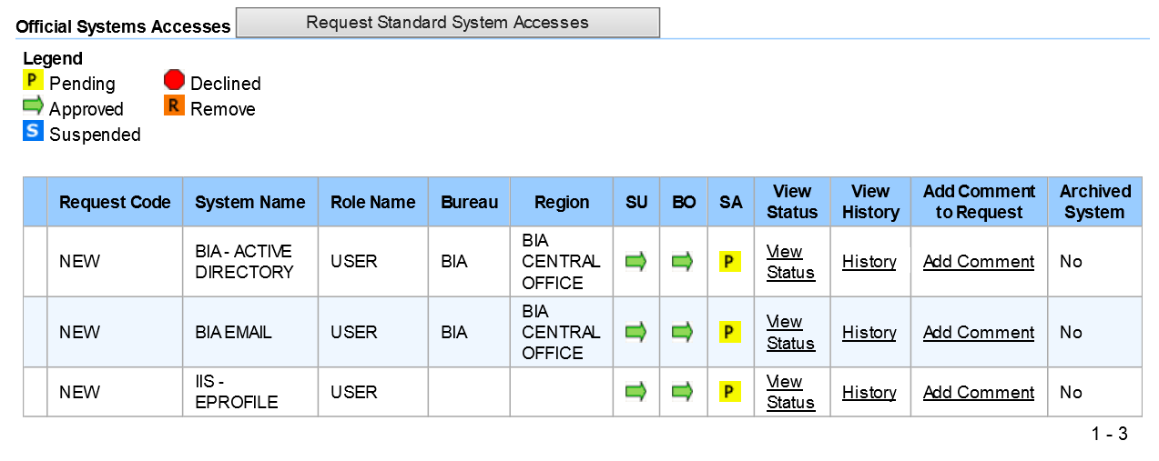

|  |
| --- |
| *Links and Help* |
| **e-QIP:** [www.opm.gov](http://www.opm.gov/) and click on “Investigations”, “e-QIP Application”, “Enter e-QIP Applicant Site” and follow the prompts.  **DOI-Access (Smartcard)**   * Check DOI Access Card Status and Site: <https://doiaccess.doi.net/app/> * Schedule appointment in (USAcess) to pick-up/activate: <https://timetrade.com/app/usaccess/workflows/usaccess001/schedule/?appointmentTypeGroupId=hspd12>   **Issues with PIV Card**, please check it against the link below. Provide screen shots of the error messages.   * <https://wiki.doi.net/cardcheck/> |
| **Human Resources (HR)**   * Geralyn Eckiwadau, Human Resources Specialist, 405-247-1603, [geralyn.eckiwaudah@bia.gov](mailto:GERALYN.ECKIWAUDAH@BIA.GOV) * Daniella “Bo” Thompson, Human Resources Assistant, 405-247-1641, daniella.thompson@bia.gov   **Personnel Security**   * Lara Willie, Security Assistant, 505-563-5294, [lara.willie@bia.gov](mailto:lara.willie@bia.gov) * Janet Nash, Security Specialist, 505-563-5238, [janet.cook@bia.gov](mailto:janet.cook@bia.gov) |

***After Favorable Screening and Before the First Day of Work***

You are now officially an Federal “Employee” contingent upon a favorable screening and have received a Confirmation Letter from HR

**Student completes the Cyber-Awareness (FISSA+) Training Course (to gain Network Access)**

The ​Federal Information Systems Security Awareness (FISSA+) DOI Rules of Behavior, Privacy Awareness, Records Management, and

Section 508 Compliance training must be completed before a new hire will be granted access by the IT to the DOI Network (aka Active Directory).

There are two ways to complete the FISSA+ Training Course.

**Option 1:** Request an DOI Learn account be manually created and complete the training in DOI Learn. Otherwise a DOI Learn account will be auto-created about 2-4 weeks after your EOD date and after HR processes the appointment action in FPPS.

**OR**

**Option 2:** Complete the training using an alternative portal, then Email a copy of the course completion certificate to your supervisor, submit a BIA Helpdesk ticket to update your DOI Learn transcript. If you chose this method, YOU MUST HAVE ACCESS TO A PRINTER to print the certificate or you will have to take training again.

All employees will need to have a DOI Learn account. The DOI Learn is the enterprise wide learning management system for DOI employees, volunteers and contractors. The system contains over 1200 instructor-led courses and over 4000 online courses, including the FISSA+ Training Course.

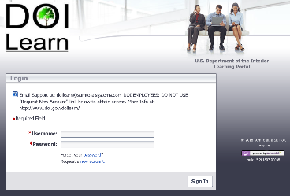

**Option 1: Steps to manually create a DOI Learn account and complete FISSA+ Training:**

* + 1. Send an Email to the DOI Learn Administrator as follows to manually create a DOI Learn account:

Email

**To:** [doilearn@bia.gov](mailto:doilearn@bia.gov)

**CC:** Program coordinator and [otspathways@bia.gov](mailto:otspathways@bia.gov)

**Subject:** Request for manual creation of a DOI Learn account

Please create a DOI Learn account for me using the following information:

My legal full name is: First Name Last Name

The Office I work for is: Office of Trust Services, Bureau of Indian Affairs

My supervisor’s name is: [Gayla Schock]

* + 1. The DOI Learn Administrator will Email the student their user name, a temporary password, and provide instructions on how to login.
    2. Login to DOI Learn at: <https://gm2.geolearning.com/geonext/doi/login.geo>
    3. Go to the [My Required Learning/By Plan](https://gm2.geolearning.com/geonext/doi/myrequiredtraining.geo?selectTab=By+Plan) tab to find and complete the FISSA+ training or you can also search:

“**2018 Cybersecurity/FISSA, Privacy Awareness, Records Management and Controlled Unclassified Information”**

* + 1. Save a copy of your completion certificate on your computer desktop (See Step 3).

**Option 2: Steps to complete FISSA+ Training via the DOI Training Streaming/Download WebPage:**

1. Complete the FISSA+ training by selecting the “Information Management and Technology (IMT) Awareness Training”at <https://www.doi.gov/doilearn/training-download>



IMPORTANT NOTES about Certificates: When taking the training, you MUST be connected to a printer and print your certificate immediately. **If you don’t print the certificate** when you reach the final screen, you may need to retake the course to access a new certificate.

OR, if your Windows has the Accessory/App called

“Snipping Tool” you can use this to screen capture the certificate

and save it as a .JPG or .PNG

1. Print or screen capture (snipping tool) your certificate immediately!
2. If print, scan a copy of the printed certificate and save it to your computer. You will have to Email a copy of the certificate to the BIA Helpdesk in the following Step 3 to request that they manually update your IIS e-Profile.

**Student Emails the FISSA+ Completion Certificate to the BIA Helpdesk to Update IIS e-Profile**

This is not required if you completed the FISSA+ training in DOI Learn. However, we still recommend you do this because it can help to establish direct contact with IT and expedite the Active Directory/Email Account Requests in IIS that are pending Approval from the System Administrator. As with your DOI Learn account, there is a lag time in the IIS e-Profile process.

* Send an Email to the BIA Helpdesk and attach a copy of the FISSA+ completion certificate as follows:

Email

**To:** biahelpdesk@bia.gov

**CC:** Program Coordinator and otspathways@bia.gov

**Subject:** Update IIS e-Profile with FISSA+ Training and Create a New User Account

Re: Reason code "New User"

Attached is my FISSA+ training completion certificate. Please ensure my IIS e-Profile reflects the FISSA+ training as completed and my information reads as follows:

My legal full name is: First Name Last Name

The Office I work for is: Office of Trust Services

Organization Code is*:* K00443 – Forestry/Fire  **OR** K00460 - Rangeland

My supervisor’s name is: Gayla Schock

*(If applicable) Also, student will need to have his/her workstation setup at [address and room number].*

* After the e-Profile has been updated in IIS, IT will approve the system generated User Account Requests for the AD/Email.
* The Supervisor will receive an email from the BIA Helpdesk providing the student’s temporary password and first-time login instructions.

|  |
| --- |
| *Links and Help* |
| **BIA DOI Learn Webpage:** <http://www.bia.gov/WhoWeAre/AS-IA/OHCM/doilearn/>  [**BisonConnect**](http://mail.doi.gov/)**:** <https://mail.google.com/mail/u/0/#inbox>  **Bison Tips and Tricks**: <https://sites.google.com/a/doi.gov/bisonconnect-resource-site/tips-and-tricks>  **Bison Support:** <https://sites.google.com/a/doi.gov/bisonconnect-resource-site/support> |

**Student completes online Government Charge Card (Cardholder) Travel Training and J.P. Morgan Application**

NOTE: This training IS NOT in DOI Learn.

Only Modules A and B

[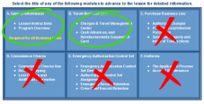](https://cctrain.ibc.doi.gov/)

* Complete the Cardholder Training, only **Modules A and B**, of the Integrated Charge Card

No

Program Cardholder Travel Training at: <https://cctrain.ibc.doi.gov/>

* Print and Save copies of your completion certificates!

No

No

No

The Pathways Program Coordinator will send the student a **Concur System Access Request Form.**

* *Use a computer to complete the* JP Morgan Cardholder Application
  + If the writing is not legible, they will not process it.
  + JP Morgan will not accept digital signatures (print and sign)
* Email the certificates along with your completed JP Morgan Application to your Pathways Program Coordinator as follows:

Email

To: BIA Pathways Official

CC:[otspathways@bia.gov](mailto:otspathways@bia.gov)

Subject: **Travel** **Cardholder Training and Application completed**

Attached are the Travel Training Completion Certificates and the completed JP Morgan Cardholder Application.



*(If Rush order) My **physical address** to FedEx my JP Morgan Card to is:

* The Agency Organization Program Coordinator (A/OPC) will process the application training. The card should arrive in 5-7 days, *unless a “Rush” order is requested via FedEx.

**As soon as you receive your Travel Charge Card,** request access to the J.P. Morgan's PaymentNet Website. You will need your charge card information. In PaymentNet, you can view transactions in live time, change your mailing address, print your statement, etc. You do not have to wait for paper copies via U.S. Postal Service, which is really important! **You can also pay online using your personal Debit/credit card(s).**

**If you pay by phone by calling the customer service number printed on the card, you WILL NOT be able to make payment with a debit/credit card. Instead, you will have to use your checking account and it will take 24 hours to process.**

* Email to A/OPC to request access to the PaymentNet as follows:

Email

To: [bradley.russell@bia.gov](mailto:bradley.russell@bia.gov) and [otspathways@bia.gov](mailto:otspathways@bia.gov)

CC:Supervisor and [otspathways@bia.gov](mailto:otspathways@bia.gov)

Subject: **PaymentNet Access**

I am requesting access to the JP Morgan PaymentNet.

My legal full name is: First Name Last Name

The Office I work for is: Office of Trust Services

* The A/OPC will Email the student their User ID, temporary password, and instructions on how to login.

Remember when you use your card, you must reconcile, sign, and return it by the deadline to the supervisor. Download a copy of the [**How to reconcile your Monthly Charge Card Statements**](https://www.bia.gov/sites/bia.gov/files/assets/bia/ots/nyrp/How%20to%20Reconcile%20your%20Travel%20Charge%20Card%20Statement%20Pathways%20Program%20Guide.pdf)

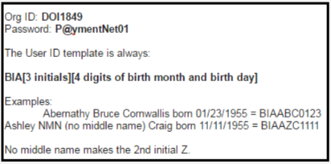

* Finally, complete First-time login at <https://gov1.paymentnet.com/>

If the password does not work, utilize the Forgot Password feature. If that does not work, contact us or your A/OPC

In PaymetNet, you’ll be able to Download and Print Your Statements!

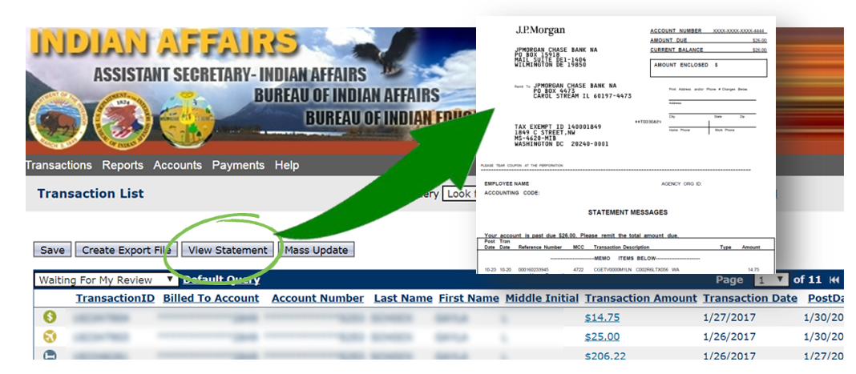

|  |
| --- |
| *Links and Help* |
| **BIA Charge Card A/OPCs:**   * Bradley Russell, 703-390-6468, [bradley.russell@bia.gov](mailto:bradley.russell@bia.gov) * Cheryl Battle, 703-390-6477, [cheryl.battle@bia.gov](mailto:cheryl.battle@bia.gov)   **Travel Support Helpdesk**: [TDYdesk@bia.gov](mailto:TDYdesk@bia.gov).  **AS-IA/BIA Charge Card Program Intranet website:** <http://iiamabqzucmw01p.ia.doi.net:16200/inside.indianaffairs/Org/AS-IA/OCFO/AP/CCS/TravPurch/index.htm>  **DOI Integrated Charge Card Program Purchase Cardholders Handbook:** https://www.doi.gov/pam/programs/chargecard/cardholders  **DOI E-Gov Travel Facts:** <https://www.doi.gov/pfm/etravel>  **Per Diem Rates**: <http://www.gsa.gov/portal/category/21287>  **DOI TDY Handbook:** <https://www.doi.gov/sites/doi.gov/files/uploads/FMM%202015-014%20Issuance%20of%20Amended%20DOI%20TDY%20Policy_0.pdf>, and Attachment: <https://www.doi.gov/sites/doi.opengov.ibmcloud.com/files/uploads/Amended%20DOI%20TDY%20Travel%20Policy.pdf> |

**Student completes the Concur System Access Request Form**

* The Pathways Program Coordinator will send the Student a **Concur System Access Request Form.** The student only needsto complete the yellow highlighted sections. Then return the form via Email as follows:

Email

To: [gayla.schock@bia.gov](mailto:gayla.schock@bia.gov)

CC:[monica.cooper@bia.gov](mailto:monica.cooper@bia.gov),[otspathways@bia.gov](mailto:otspathways@bia.gov)

Subject: **Concur System Access Request Form** **completed**

Attached the Concur Form

* If the student has access to a government computer, the Pathways Program Coordinator will also request that the student be given access to Concur to activate the account.
* The Concur Team will email the student (to their BIA Email Account) a User ID, temporary password, and login instructions.

Concur Team, IA Emails: [ia_concur_team@bia.gov](mailto:ia_concur_team@bia.gov)

**Before the student can Login, they must have an active BIA email**

* Login at:<https://cge.concursolutions.com/>
* In the upper right hand corner, click on the “Profile” drop down and select the “Profile Setting” link and update your personal information.
* You must add your JP Morgan card information into the “[Credit Card Information](https://cge.concursolutions.com/profile/PersonalProfile.asp#CreditCards)” section.



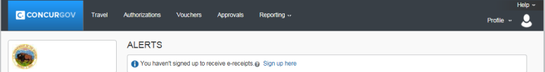





**Now that the account is activated, the employee can access Concur using a smart phone!**

|  |
| --- |
| *Links and Help* |
| **ConcurGov Questions/Assistance/Issues/Login & Password Resets?**  **DOI Travel Help Desk,** [**travel_helpdesk@ios.doi.gov**](mailto:travel_helpdesk@ios.doi.gov)  **Concur Helpdesk:** 1-855-847-6398 Option 1  **Concur Application Portal:** <https://cge.concursolutions.com/>  **BIA Concur SharePoint site:** <https://sp.ia.doi.net/sites/ASIA/ocfo/IAConcur/default.aspx> |

**Student completes the QuickTime (QT) training, and if Applicable Request QT User ID and Password.**

This training IS NOT in DOI Learn.

* Complete QuickTime Student eLearning Training at: <https://hrdtrainingportal.ibc.doi.gov//DMARTPORTAL/?LOAD=1&PGID=117#Quicktime>
* Student Emails a copy of the completion certificate to the QT Administrator as follows:

Email

**To:** [monica.cooper@bia.gov](mailto:monica.cooper@bia.gov) (If she is out of office, send to [carl.cook@bia.gov](mailto:carl.cook@bia.gov) )

**CC:** Program coordinatorand [otspathways@bia.gov](mailto:otspathways@bia.gov)

**Subject:** New Employee - BIA QuickTime Access

Attached is a QuickTime Employee Training Completion Certificate. I am requesting

QuickTime Employee ID and Password using the following information:

My legal full name is: First Name Last Name

The Office I work for is: Office of Trust Services

Organization Code is *(Choose One):* K00443 – Forestry/Fire **or** K00460 - Rangeland

My supervisor’s name is: Gayla Schock

* The QT Administrator may need to request your SSN to manually create an account for you. They will Email you your User ID, temporary password, and instructions on how to login if the student has access to a Government Computer.

|  |
| --- |
| *Links and Help* |
| **DOI Wiki:**  <http://wiki.doi.net/DOIWiki/index.php/Main_Page>  **BisonConnect:** <http://wiki.doi.net/DOIWiki/index.php/BisonConnect>  **Pathways QuickTime Program Administrator:** monica.cooper@bia.gov  **QuickTime Training:**  <https://hrdtrainingportal.ibc.doi.gov/DMARTPORTAL/?LOAD=1&PGID=117>  **QuickTime Help:** ttps://www3.ibc.doi.gov/services/hr/Quicktime/SSA_nonewd/WebHelp/qtime.htm  **Leave and Attendance**   * [IBC QuickTime Site](https://www3.ibc.doi.gov/services/hr/Quicktime/index.cfm) * [DOI Leave Handbook](http://elips.doi.gov/elips/0/doc/3302/Page1.aspx) & [IA Leave Handbook](https://iiamabqzucmw02p.ia.doi.net:16200/cs/groups/xraca/documents/text/idc-000594.pdf) (PDF) * [Time and Attendance Guide](https://www3.ibc.doi.gov/services/hr/payroll/manuals/docs/TAReferenceGuide.pdf)  (PDF) &[Timekeepers Handbook](https://iiamabqzucmw02p.ia.doi.net:16200/cs/groups/public/documents/text/idc-005844.pdf) (PDF) |

**If the Host Office will provide the student access to a government owned computer, then the student can complete a BIA Email First-Time Login.**

* 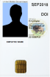Work with your local admin officials (Host Office) to submit a BIA Helpdesk ticket to log into the system and complete the first-time login process. You will need:
* The Email sent to your supervisor with the PW and login instructions.
* Access to a government owned computer
* Smartcard
* Submit a new BIA Helpdesk Ticket to request new employee work station set-up. A local IT official will be assigned to assist you.

**Reminder: If you will do not access you Email with a BIA computer, your Email account will be deactivated after 30 days.** To reactivate, simplysend an Email to the BIA Helpdesk with the following reason code:

**Subject:** BIA Email Account Reactivation Request

Re: Reason code "Restore (Reactivate) Account"

And to request email suspension be "overridden”

**AD ACCOUNTS MAY ALSO BE DISABLED DUE TO TRANSMISSION OF SENSITIVE INFORMATION**

See attachment #2 **“Steps for Supervisors To Take to get Employees Account Restored”** issued in Apr 2017 by the Division of Information Security (DIS) and the Privacy Officer provide guidance to Supervisors of employees whose AD account has been disabled due to transmission of sensitive, inappropriate or PII data outside the DOI.

OTS Pathways Only

Quicktime - Time and Attendance Accounting Information

THIS MUST BE UPDATED EVERY NEW FY

|  |  |  |  |  |  |
| --- | --- | --- | --- | --- | --- |
| **Program**  **Hired Under** | **Part I(b): New User Information/Current Profile** | | | **Part V: Travel Reviewers or Approvers Only** | |
| **Default Line of Accounting (LOA) – FY 2018:** | **New Duty Station Street Address & City/State/Zip:** | **New Routing List Name** | **Name** | **Role** |
| Fire | 18XA1125TR/AAK4004403/AF1004040.999900/AF.PPFTRAIN00.000 | * This is the Student’s College or University Address (Where they Physically Attend Classes | K00443 Forestry Projects - Student | Gayla Schock | Approver |
| Forestry | 189A2100DD/AAK4004403/A0N3E7070.999900 | K00443 Forestry Projects – Student | Gayla Schock | Approver |
| Rangeland | 187A2100DD/AAK4004600/A0N9B1010.999900 | K00460 Division of Natural Resources | Gayla Schock | Approver |

**Steps for Supervisors To Take to get Employees Account Restored do to PII Violations**

The Division of Information Security (DIS) and the Privacy Officer provide guidance to Supervisors of employees whose AD account has been disabled due to transmission of sensitive, inappropriate or PII data outside the DOI. In order to get the employee’s email account restored, the following steps need to be followed:

* Council your employee on Handling Sensitive Information Within Indian Affairs.
* Assist your employee with retaking the 2017 FISSA Training through DOI Learn.
* After training is completed, employee must print a certificate of completion. If date is correct, it will be accepted. If the date is not current, please take a screenshot of the Online Training (OLT) activity of the FISSA Training (see below).
* The certificate or OLT activity will need to be scanned and emailed to the BIA CIRT at bia_socc@bia.gov. Once received the BIA CIRT will generate an email to have the user account re-enabled.
* You and your employee will be advised when confirmation is received that the account has been restored.

Any questions should be directed to BIA CIRT at 703-390-6777 or to the Indian Affairs Privacy Act Officer, Scott Christenson, at 612-725-4518 or biaprivacy@bia.gov.

