Bureau of Indian Affairs, Office of Indian Services
Division of Human Services
Webinar Training Event

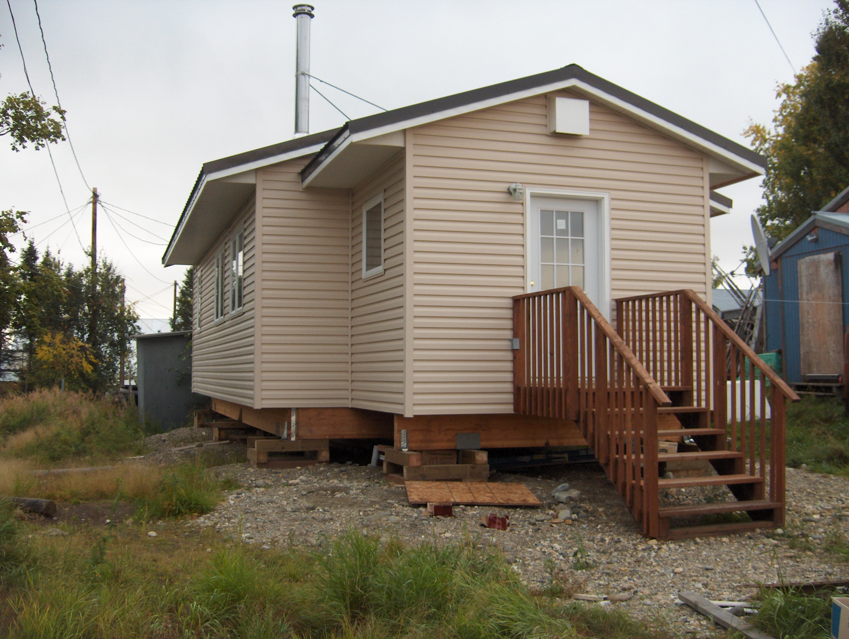

- Webinar #1: Housing Improvement Program (HIP) Tribal Annual Performance Report
Date: Wednesday December 11, 2019 – 1:00pm to 2:30pm EST
Overview: This webinar training session will provide an overview on the Housing Improvement Program Tribal Annual Performance Report (TAPR). The TAPR is due to the Regional offices December 31, 2019. The target audience for each webinar training session is tribal leaders, tribal program staff who operate the HIP, BIA Agency programs, BIA Superintendents and anyone interested in learning more about the BIA Housing Program.

Additionally, tribal entities should continue to seek Technical Assistance from the BIA agency or Regional Office who are responsible for all Bureau Housing Program activities within their defined geographical area.

To register for this webinar session, please click on the hyperlink below and use the event password, if prompted. You will need to use the event password to retrieve the Training Materials.
Webinar Training Session - HIP  Date: Wednesday, Dec 11, 2019  Time: 1:00pm to 2:30pm EST  Call in telephone line #  Event Number: 877-417-9689  Event Password: 1730174 | Webinar Link:  https://bia-ois-hsevents.webex.com/bia-ois-hsevents/onstage/g.php?MTID=e91044594d84ed406a4f1cf2987edefb2  Event Number: 824 264 367  Event Password: nrdNmVut

You can learn more about the Housing Improvement Program at:
https://www.bia.gov/bia/ois/dhs/housing-improvement-program

Point of Contact: Mr. Les Jensen, Housing Program Manager at leslie.jensen@bia.gov

